**SIMULATION OF PHASE DETECTOR OF PLL**

**Circuit Diagram:**

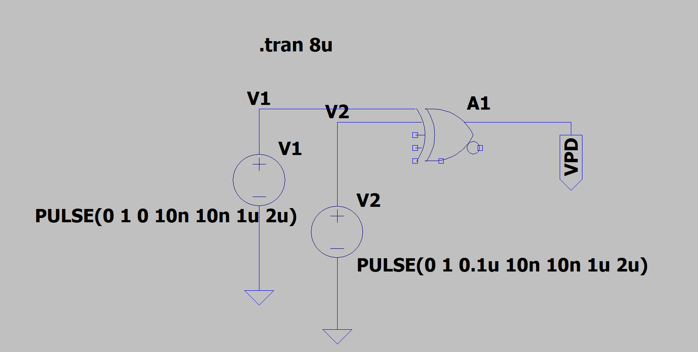

**Output for little delay:**

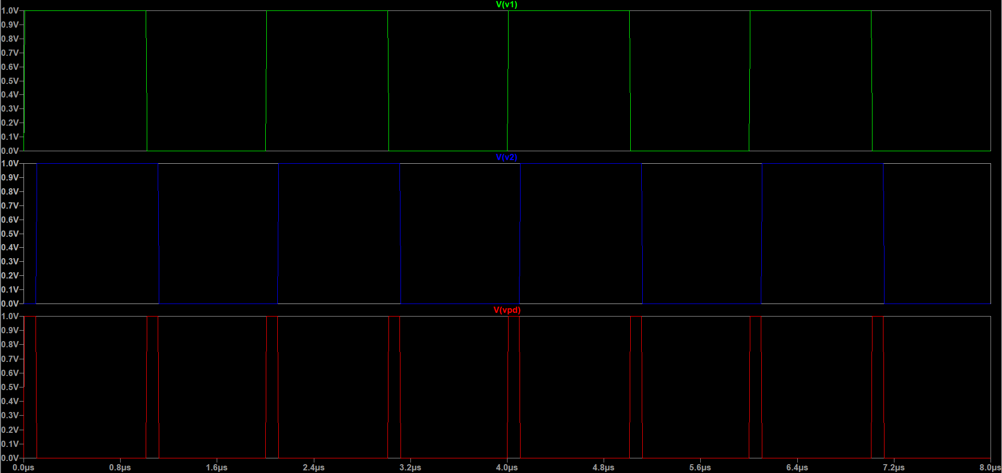

**Output for Delay of Π/2:**

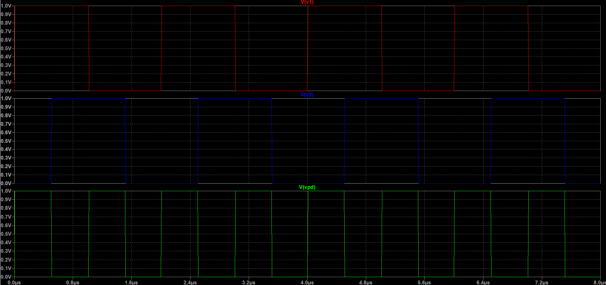

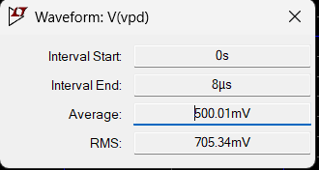

**Average is 500mv  
phase difference Π/2  
  
So, KPD = 1000\***